Data Structure and Algorithm

Laboratory Activity No. 2

Algorithm Analysis and Flowchart

|  |  |
| --- | --- |
| *Submitted by:* | *Instructor:* |
| Gabuyo, Ivan love D. | Engr. Maria Rizette H. Sayo |

July, 26, 2025

# Objectives

Introduction

Data structure is a systematic way of organizing and accessing data, and an algorithm is a step-by-step procedure for performing some task in a finite amount of time. These concepts are central to computing, but to be able to classify some data structures and algorithms as “good,” we must have precise ways of analyzing them.

This laboratory activity aims to implement the principles and techniques in:

* Writing a well-structured procedure in programming
* Writing algorithm that best suits to solve computing problems to improve the efficiency of computers
* Convert algorithms into flowcharting symbols

# Methods

* 1. Explain algorithm and flowchart

-x, x<0

x, x ≥ 0

* 1. Write algorithm to find the result of equation: f (x) = and draw its flowchart
  2. Write a short recursive Python function that finds the minimum and maximum values in a sequence without using any loops

# Results

A.

Algorithm  
  
 A programming algorithm is a procedure or formula used for solving a problem. It is based on conducting a sequence of specified actions in which these actions describe how to do something, and your computer will do it exactly that way every time. An algorithm works by following a procedure, made up of inputs. Once it has followed all the inputs, it will see a result, also know nasoutput.  
  
Flowchart

An algorithm, workflow, or process can be represented by a flowchart. The steps are represented by boxes of different types in the flowchart, and arrows are used to connect the boxes to indicate their order. This diagrammatic representation shows a model for solving a particular problem. Flowcharts are used in many different sectors for process or program analysis, design, documentation, and management.

Figure 1. Flow chart

B.

Algorithm

Step 1: Start

Step 2: Input the value of x

Step 3: If x < 0, then f = -x

Step 4: Else f = x

Step 5: Output the value of f

Step 6: End

Flowchart

1. Start

2. Input xIs x < 0?

3. If Yes, go to step 4

4. If No, go to step 5

5. f = -x

6. f = x

7. Output f

9. End

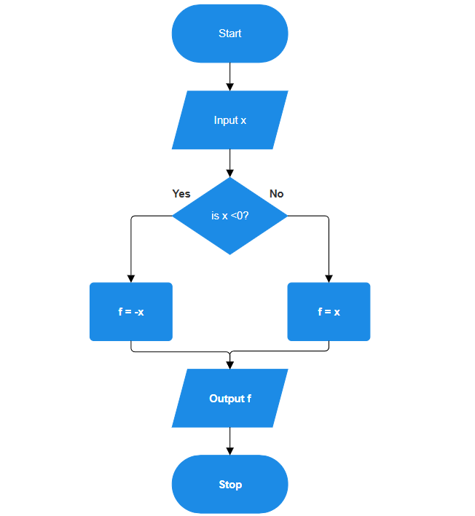

Figure 2. Flow chart

C.

def find_min_max(seq):

# Handle empty list case

if not seq:

raise ValueError("The sequence is empty.")

# Base case: only one element

if len(seq) == 1:

return seq[0], seq[0]

# Recursive case

min_rest, max_rest = find_min_max(seq[1:])

return min(seq[0], min_rest), max(seq[0], max_rest)

# Example usage

numbers = [11, 9, 23, 6, 5, 3]

minimum, maximum = find_min_max(numbers)

print("Min:", minimum)

print("Max:", maximum)

Figure 3. Source code

# Conclusion

Through this laboratory activity, I gained a clearer understanding of how algorithms and flowcharts aid in solving problems systematically. Writing out procedures and then translating them into flowcharts made the logic easier to visualize and follow. It also helped me identify any gaps or errors in the process more effectively.

I found the section on recursive functions particularly interesting, as it demonstrated how certain problems can be solved without relying on loops. This concept expanded my perspective on different approaches to programming.

Overall, this lab greatly enhanced my problem-solving skills and reinforced the importance of planning and structuring solutions before jumping into writing code. It emphasized how a well-thought-out algorithm and flowchart can make the coding process more efficient and accurate.

**References**

[1] “What is a programming algorithm? Data defined - indicative,” Indicative, Sep. 15, 2021. <https://www.indicative.com/resource/programming-algorithm/>

[2] K. L. Busbee, “Flowcharts,” Programming Fundamentals, Dec. 15, 2018. <https://press.rebus.community/programmingfundamentals/chapter/flowcharts/>

[3]“W3Schools.com.” <https://www.w3schools.com/python/gloss_python_function_recursion.asp>